Hung Tran

**Game Design Document**

1. Introduction:

God knows takes place in a legendary island Avalon where the Holy sword Excalibur is sealed. Our main protagonist is King Arthur’s descendent named Akira and her obligation is to unseal the sword and rebuild the Great Britain Empire.

1. Marketing:

Fans of anime will be greatly attracted by God knows. God knows will be rated at 15+ and we commit not to use bloody content.

High Concept:

God knows is a three-dimensional RPG game where players clear every single object to win.

1. Gameplay:

-First Minute: The player has a short conversation with our game master- Lady of the Lake, and then she will give the player a blessing which is +100 armor and start the fight.

-Controls: the players will control the character by using “WSAD”, “JKL” and Space. “WSAD” are for basic movements, Space is for jump, “JKL” are for attack moves.

-Victory conditions: the players must clear as many obstacles as possible to gain the power or more accurately prove their worthiness to Excalibur.

1. Technology:

I will use C# and Unity Engine 5.4 to make the game, platforms will be Windows 10 and Android 6.

The codes are written in Microsoft Visual Studio 2015.

1. Art:

-Characters: Akira (Unity Chan), Lady of the Lake (Sapphire Chan), the butchers, zombies, skeletons

-Items: Blu-Excalibur, Butcher-Dagger

1. Sound:

Mousou Express  
Nano Desu  
Fighting Soundtracks

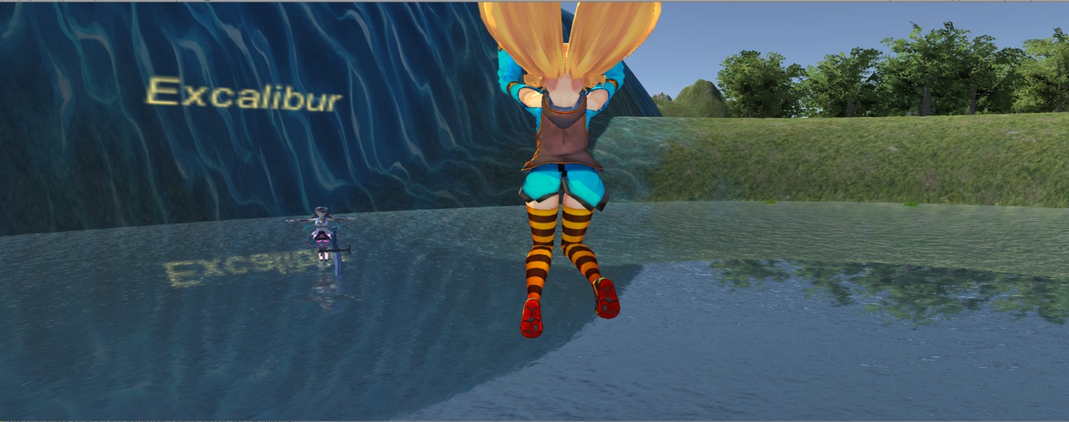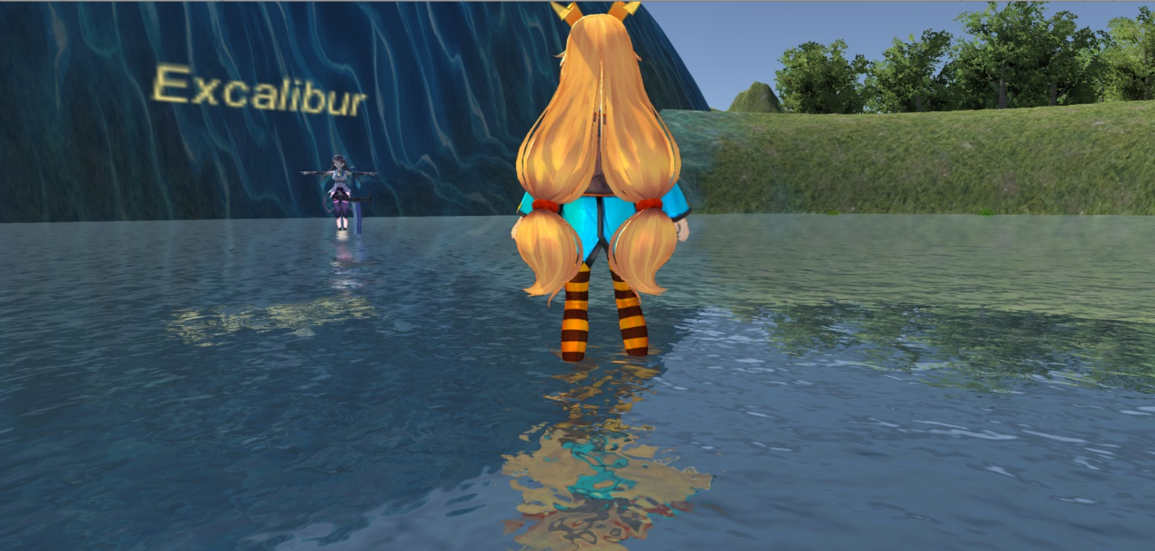First look at the game

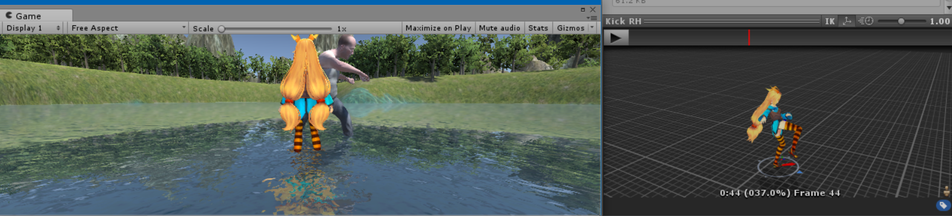Very intense fight scene

Lady of the Lake and Excalibur 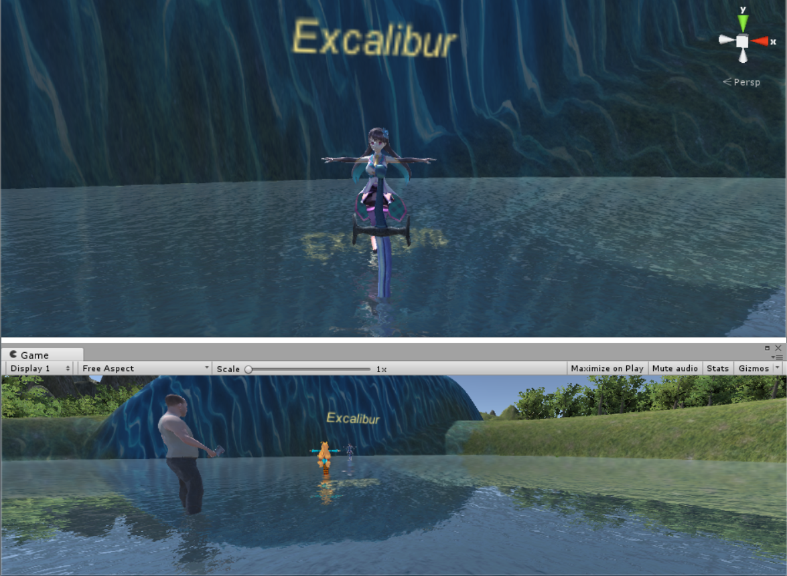

Avalon island 